1.

<!DOCTYPE html>

<html lang="en">

<head>

<meta charset="UTF-8">

<meta name="viewport" content="width=device-width, initial-scale=1.0">

<title>Positioning Boxes</title>

<style>

body {

font-family: Arial, sans-serif;

margin: 0;

padding: 0;

}

.container {

position: relative;

width: 300px; /\* Adjust as needed \*/

height: 300px; /\* Adjust as needed \*/

margin: 200px auto; /\* Center the container \*/

}

.box {

width: 50px;

height: 50px;

background-color: #333;

position: absolute;

}

.box-a {

top: 200px;

left: 200px;

}

.box-b {

top: calc(200px - 30px);

left: calc(200px - 30px);

}

.box-c {

top: calc(200px - 30px);

right: calc(200px - 30px);

}

.box-d {

bottom: calc(200px - 30px);

left: calc(200px - 30px);

}

.box-e {

bottom: calc(200px - 30px);

right: calc(200px - 30px);

}

</style>

</head>

<body>

<div class="container">

<div class="box box-a"></div>

<div class="box box-b"></div>

<div class="box box-c"></div>

<div class="box box-d"></div>

<div class="box box-e"></div>

</div>

</body>

</html>

2.

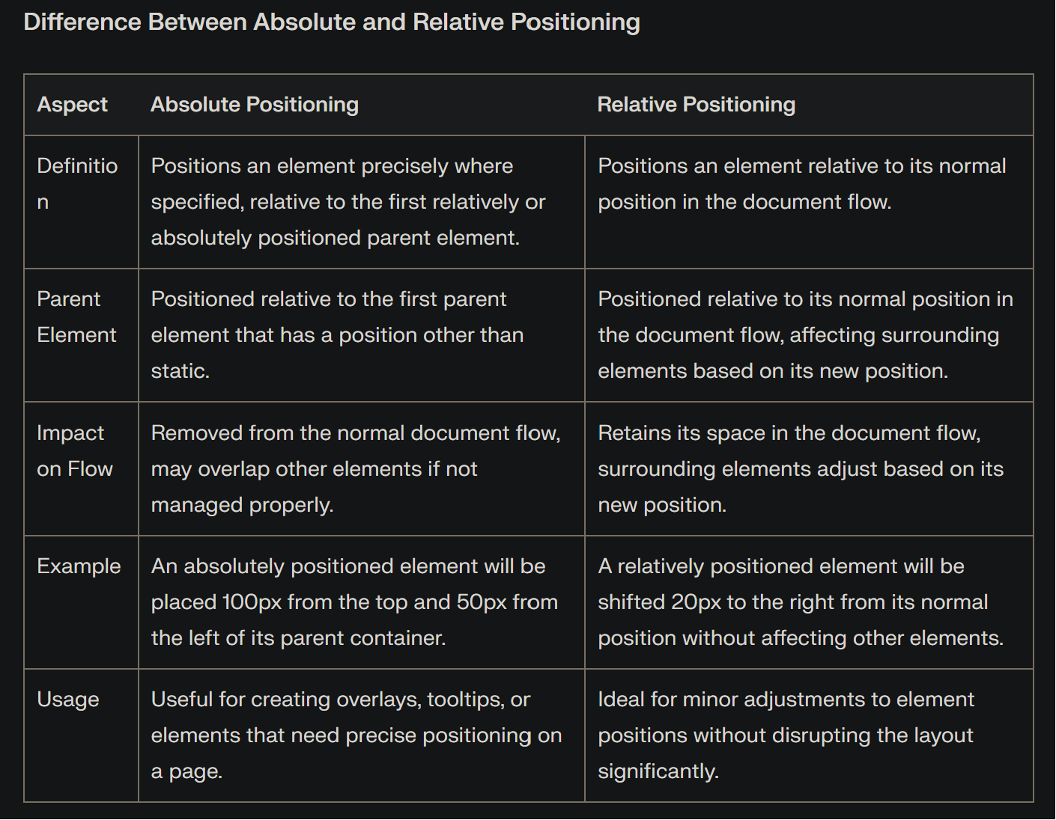

3.

<!DOCTYPE html>

<html lang="en">

<head>

<meta charset="UTF-8" />

<meta name="viewport" content="width=device-width, initial-scale=1.0" />

<title>Document</title>

<link rel="stylesheet" href="index.css" />

</head>

<body>

<div class="card">

<img

class="card-image"

src="https://random.imagecdn.app/300/180"

alt="random image"

/>

<div class="card-body">

<h3 class="card-title">The Earth!!!</h3>

<p>

Nature is Earth's masterpiece, a symphony of life composed through

millennia. Its landscapes whisper tales of ancient mountains, winding

rivers, and flourishing forests, reminding us of the planet's

boundless beauty. From delicate petals to towering redwoods, nature's

artistry stirs awe and reconnects us to the essence of existence.

Nature is Earth's masterpiece, a symphony of life composed through

millennia. Its landscapes whisper tales of ancient mountains, winding

rivers, and flourishing forests.

</p>

</div>

</div>

</body>

</html>

.card {

padding: 10px;

background-color: beige;

border-radius: 5px;

}

.card-image {

float: right;

padding-left: 10px;

padding-right: 10px;

}

4.

<!DOCTYPE html>

<html lang="en">

<head>

<meta charset="UTF-8">

<meta name="viewport" content="width=device-width, initial-scale=1.0">

<title>Sticky Header</title>

<link rel="stylesheet" href="style.css">

</head>

<body>

<header>

<h1>My Website</h1>

<nav>

<ul>

<li><a href="#">Home</a></li>

<li><a href="#">About</a></li>

<li><a href="#">Services</a></li>

<li><a href="#">Contact</a></li>

</ul>

</nav>

</header>

<p>Lorem ipsum dolor sit amet, consectetur adipiscing elit.

Donec at libero venenatis, vulputate magna quis, placerat eros. Morbi leo risus, porta ac consectetur ac,

visac sit amet lacus. Morbi leo risus, porta ac consectetur ac,

visac sit amet lacus. Sed posuere consectetur est at lobortis.

Aenean eu leo quam. Pellentesque ornare sem lacinia quam venenatis

vestibulum. Donec id elit non mi porta gravida at eget a libero.

Donec sed odio dui. Aenean eu leo quam. Pellentesque ornare sem

lacinia quam venenatis vestibulum. Donec id elit non mi porta

gravida at eget a libero. Donec sed odio dui.</p>

</body>

</html>

header {

background-color: #333; /\* Change background color as desired \*/

color: #fff; /\* Change text color as desired \*/

padding: 1rem 2rem;

display: flex;

justify-content: space-between; /\* Distribute elements horizontally \*/

position: sticky; /\* Make the header sticky \*/

top: 0; /\* Position it at the top of the viewport \*/

z-index: 10; /\* Ensure it stays on top of other elements \*/

}

nav {

display: flex;

list-style: none; /\* Remove default bullet points \*/

margin: 0; /\* Remove default margin \*/

padding: 0; /\* Remove default padding \*/

}

nav li {

margin-right: 1rem;

}

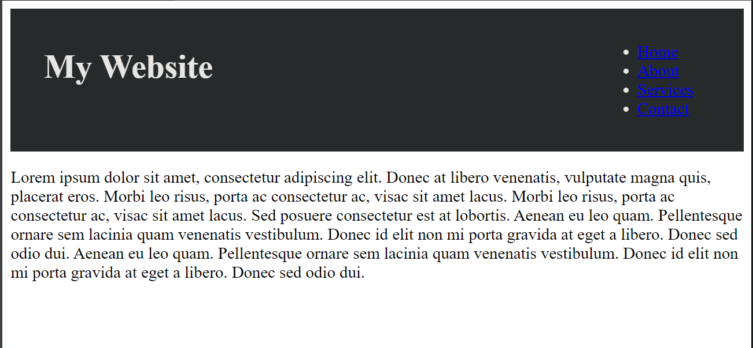

5.

<!DOCTYPE html>

<html lang="en">

<head>

<meta charset="UTF-8">

<meta name="viewport" content="width=device-width, initial-scale=1.0">

<style>

.box {

width: 100px;

height: 100px;

position: absolute;

background-color: #3498db;

color: white;

text-align: center;

line-height: 100px;

}

.box1 {

z-index: 1;

left: 50px;

top: 50px;

}

.box2 {

z-index: 2;

left: 80px;

top: 80px;

background-color: #e74c3c;

}

.box3 {

z-index: 3;

left: 110px;

top: 110px;

background-color: #2ecc71;

}

</style>

<title>Z-index Example</title>

</head>

<body>

<div class="box box1">1</div>

<div class="box box2">2</div>

<div class="box box3">3</div>

</body>

</html>

selector {

z-index: value;

}

